## exaktQuickstart Outputting and saving search results

A. Outputting file in HTML or XML

In order to print, use them inside a word processor (e.g. MS Word) or further process your search results in the *EXMARaLDA Analysis and Concordancing* *Tool* in some other application (e.g. MS Excel), you have several options.

Choose Concordance > Save Concordance as... in order to save the whole KWIC concordance to a file. The file dialog gives you a choice between “HTML” and “XML”.

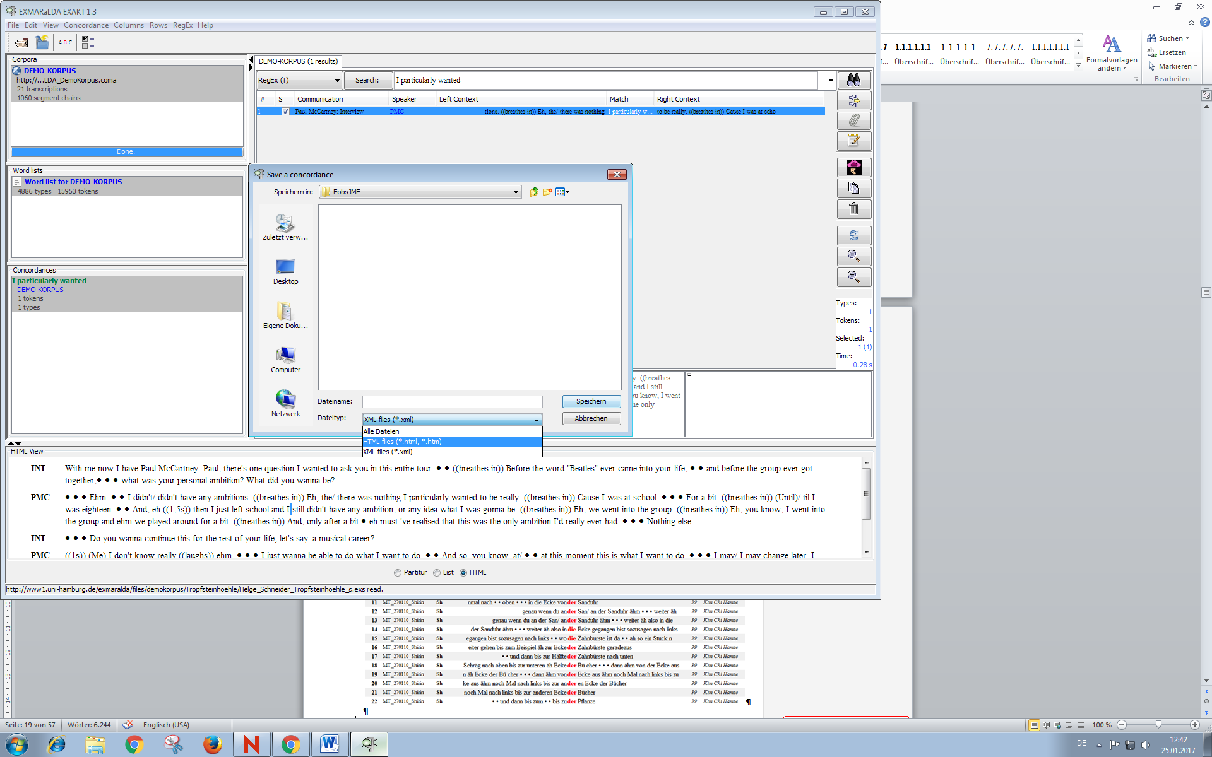

Saving as “HTML” enables you to open the resulting file in a browser, in a word processor or in any other application which reads HTML (e.g. MS Excel). By default, a built-in stylesheet is used to generate the HTML. In a browser, an exported HTML will look something like this:

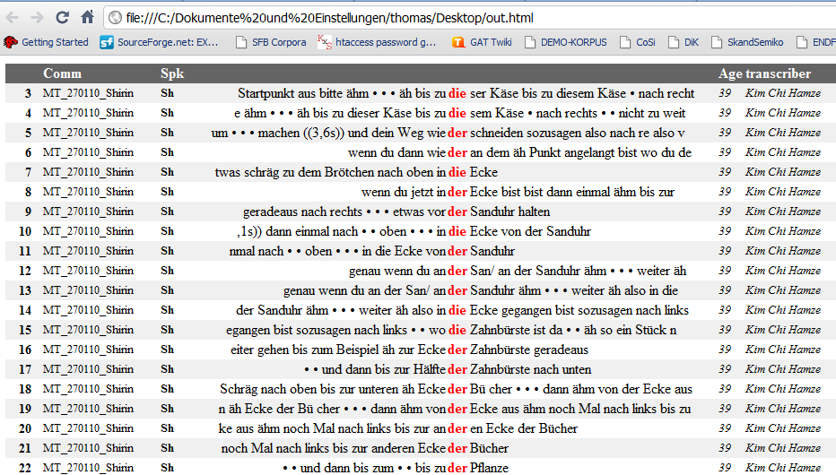

If you want to change the appearance, you can write a custom XSL stylesheet and tell EXAKT to use it, please apply appropriate settings via Edit > EXAKT Preferences... > Stylesheets > Concordance Output.

B. Copying a selection

If you want to copy and paste a selection of search results into your word processor, simply make the selection inside the concordance then choose Edit > Copy Selection or press the “Copy” button beside the concordance. The selected search results will be copied to the clipboard and you can paste them from there.

You can also use Ctrl **+** C on your keyboard, or the “Copy” button from the Partitur’s context menu (below concordance window in EXAKT) to copy a part of the transcription to the clipboard: Simply select the part you wish to copy, right-click on it and choose “Copy” or use the keyboard shortcuts:

The graphic below offers a visualisation after pasting a selection of search results into the word processor.

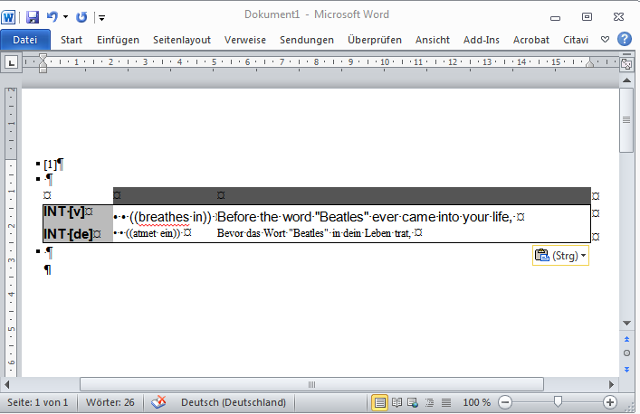

C. Saving and re-opening

Sometimes (especially if you have added manual annotations to a KWIC concordance), you might want to save a search result in order to re-open it in EXAKT itself.

To do so, proceed as follows:

1) Choose Concordance > Save Concordance as...

2) Select the “XML” option and specify a filename

3) To reopen the search result: first open the corpus from which it was derived

4) Then select this corpus in the corpus list and choose Concordance > Open concordance...

Of course, you can also use the exported XML file to do your own further processing of the search results (e.g. by transforming them via an XSL stylesheet).